**Phase 5: Apex Programming (Developer)**

Goal: Add advanced logic.

1. **Classes & Objects**

**Service Class: AppointmentService.cls**

* + This is a **helper class** that holds all the business logic for appointments.  
    It makes your code **reusable** and keeps your trigger clean.
  + **What it does:**
    1. **scheduleAppointment()** → Sets the status to "Scheduled" (if date is today or future).
    2. **completeAppointment()** → Marks an appointment "Completed" only if the date is today or past.
    3. **cancelAppointment()** → Marks an appointment "Cancelled".

**Test Class: AppointmentServiceTest.cls**

* This is used to **prove that your code works** and to get Salesforce’s required **75%+ coverage**.
* **What it does:**
  1. **Creates test Contacts (customers)** → since Appointment__c links to Customer__c.
  2. **Creates test Appointments** → scheduled for today or future.
  3. Tests:
     + Scheduling an appointment (should be "Scheduled").
     + Completing an appointment (status changes to "Completed").
     + Cancelling an appointment (status changes to "Cancelled").

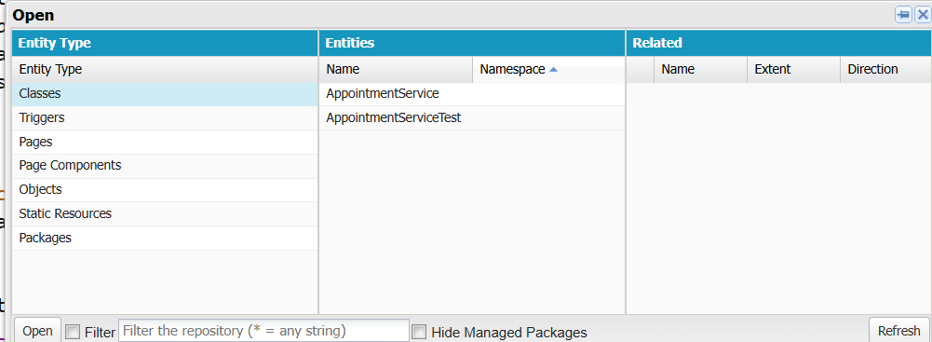

1. **Apex Triggers  
     
   Trigger: AppointmentTrigger**
   * This runs automatically when **Appointment__c** records are inserted or updated.
   * **What it does:**
     1. **On Insert (new appointment):**  
        Calls scheduleAppointment() → ensures new appointments always start with correct status.
     2. **On Update:**
        + If status changed to "Completed" → calls completeAppointment().
        + If status changed to "Cancelled" → calls cancelAppointment().

